New York State Council
Knights of Columbus
High School
Tuition Grant Program

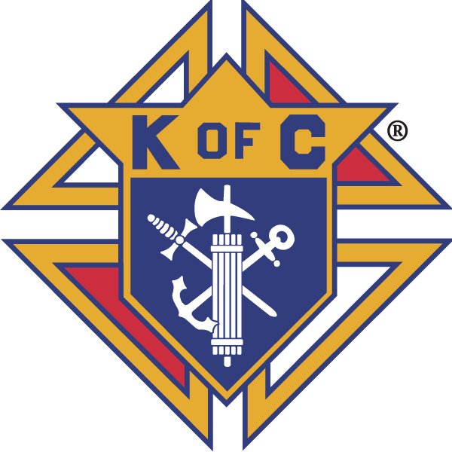

GRANT
APPLICATION
*** IMPORTANT***
Filing Deadline:
Applications for applicants entering the 9th grade must be submitted in time to be received at the NY State Council’s Executive Office NO LATER THAN APRIL 10th preceding the September school start-up date upon which the applicant plans to enter high school.
Completed Tuition Grant applications must be submitted to:
New York State Council Knights of Columbus
% Neil DeRosa
374 New York Ave.
Massapequa Park, NY 11762

PLEASE READ CAREFULLY
NEW YORK STATE COUNCIL KNIGHTS OF COLUMBUS
SCHOLARSHIP GRANT PROGRAM
PURPOSE: To provide Financial Assistance to dependent children, grandchildren and legal wards of Knights of Columbus for the furthering of their Catholic High School education.
TUITION GRANT AWARDS: Based upon the financial need of the family. Because of the sensitive nature of the information required, the Committee will only see that part of the application which contains the material necessary to award a grant and not who is applying. Applicants MUST supply all the information specified under "REQUIREMENTS" below.
Eight (8) Tuition Grants will be awarded to INCOMING 9th Grade students entering a New York State Catholic High School. One tuition grant in the amount of $500.00 will be awarded for each diocese in the State of New York provided an application is received from that diocese. Remaining award money may be returned to the Scholarship Fund. Awards must be renewed for each subsequent year the student attends a New York State Catholic High School by submitting a renewal tuition invoice. Total Award $2000.00.
REQUIREMENTS:
- Applicant must be a son, daughter, grandchild or legal ward of a Knight of Columbus in good standing. Children of deceased members whose demise occurred while in good standing are also eligible.
- Acceptance in a New York State Catholic High School for the school year beginning in September of that year. PROOF OF ACCEPTANCE IS REQUIRED.
- All applications should bear the council seal and MUST have the signature of the Grand Knight and the Financial Secretary verifying good standing of the sponsor member.
- Signatures of Parent or Guardian and the Sponsoring Member (if different from Parent) are required to certify the accuracy of all information appearing on the application. Current W-2 and 1040 Forms MUST accompany all Grant Applications.
- After the first year, renewal information must be submitted for continuation of the Tuition Grant for each consecutive year (up to a maximum of 3 additional years). Renewal will depend upon continued attendance in a New York State Catholic High School and maintenance of a scholastic record that is satisfactory, as well as evidence of continued financial need (current W-2 and 1040 forms).
- Financial need will be the deciding factor as is obvious from the confidential information requested on the application. Because of the sensitive nature of the information, the committee will only see that part of the application which contains this material.
- Failure to answer all questions completely or to obtain the required signatures will be cause for disqualification or return of the application. Write "NONE", "NO", or “NA" if any questions do not apply.
- NOTE: Any documents received other than those specified will not be considered in the decision of the Selection Committee. THE DECISION OF THE COMMITTEE IS FINAL.
OTHER RELATED INFORMATION
- For purposes of filing, the location of the Sponsoring Member's Council decides the diocese of residence.
- A student entering the 9th grade of a New York State Catholic High School may apply for both a Tuition Grant and a Scholarship Award, but may receive ONLY one or the other.
- Payments of Tuition Grant Awards are made annually after July 1st of the new school year, and mailed directly to the Catholic High School, provided the student’s current tuition statement is received in the State Office.
- Tuition Grant notification will only be made by letter from the New York State Knights of Council Chairman.
ONLY WINNERS WILL BE NOTIFIED.

Control Number: _____________
New York State Council
Knights of Columbus
High School Tuition Grant Program
ALL LINES ARE REQUIRED TO BE FILLED
PLEASE PRINT CLEARLY
Student Name: _______ ___
Address: _______________________________________________________________________
City: ______________________________________ State: _____ Zip: __________
Signature of Applicant: ______________
Years at present address: _________ Telephone #: ____________________

Date of Birth: Age: _____
Current School: _________________________________________________________ Grade ______
School to which Student HAS BEEN ACCEPTED:
Name: __________________________________________________________________
Address: ________________________________________________________________
City: ___________________________________ State: _____ Zip Code: _____________
Entering Grade: ________
I vouch that all information given is true and I will present the required proof if requested.
I also give permission to obtain the Diocesan High School test scores, if applicable or needed.

Parent/Guardian Signature: _______________________________________________
Contact Email address: ________________________________________________________
Sponsored by (circle one): Father Grandfather
Sponsor’s Name _______________________________________
Council Name __________________________________ Council Number: ________ District Number:______
Grand Knight Signature: ________________________________________
Financial Secretary Signature: ________________________________________
Council Seal (where available)

- OTHER FINANCIAL ASSISTANCE
Will student be receiving any other financial assistance or scholarships? YES NO
If YES, ANNUAL amount: $___________
IF YES, list organization(s): __________________________________________________
- FATHER’S EMPLOYER: __________________________________________________________
Address: __________________________________________________________________________
Annual Gross Salary: $____________ Years of Service: ________
Occupation/Position: __________________________/____________________ Age: _______
If not employed is Father disabled? _______ Term of Disability: _____________
- MOTHER’S EMPLOYER: _________________________________________________________
Address: __________________________________________________________________________
Annual Gross Salary: $____________ Years of Service: ________
Occupation/Position: __________________________/____________________ Age:_______
If not employed is Mother disabled? Term of Disability: _
- OTHER SOURCES OF INCOME:
Working Children: $___________ Union: $___________ Social Security: $_____________
Insurance: $___________ Savings Accounts: $_________Welfare: $_________Pensions: $_________
- FAMILY INFORMATION: Number of Dependent Children: ______
Living Home: ____ In School: ______ Working: ______
List Child(ren)'s Name, Age, School Attending, Grade:
__________________________________________________________________________________
__________________________________________________________________________________
__________________________________________________________________________________
- INDEBTEDNESS INFORMATION
Home: Own: ____ Rent: ____
Monthly Rent: $___________ Mortgage Payment (w/o Taxes): $___________
Yearly: $____________Annual Real Estate Taxes: $_ _________
- OTHER FINANCIAL OBLIGATIONS
Type Bank/Finance Company Unpaid Balance Monthly Payment

- Attach copies of all Federal Income Tax Forms for previous year which just ended.

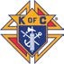
For Further Information please contact:

516-900-KofC(5632)
NYSKOFC@gmail.com

